7. Permanent Establishments (PE)

This instruction describes the handling of Permanent Establishments (PE) from a Compliance point of view and focuses on Compliance risks and their mitigation.

A PE is a legally dependent business form via which a non-resident company (parent/mother entity) establishes a presence in a country of activity. A PE arises de facto as a result of certain business activities of a parent entity (ARE) in an activity country different from its country of residence over a certain period of time.

For Compliance risks in connection with PEs, see Chapter H. 7.1.

|  |
| --- |
| Permanent Establishment principles  Responsibility for PE throughout their lifecycle always lies with the legal parent entity (ARE).  The CEOs of the parent entity (ARE) have the main responsibility to ensure Compliance in their area of responsibility, including PE and business and projects executed via a PE.  The PE can only be closed after all (e.g. legal, Compliance, HR and tax) obligations have been fully met. |

The following instruction provides the main regulatory framework for business activities rendered abroad by Siemens AG and affiliated companies:

* [Financial Reporting Guidelines (FRG) Implementation Guidelines (Chapter 19, Permanent Establishments),](https://webbooks.siemens.com/public/FRG/IGen/)
* [Siemens Circular No. 202 “Compliance with tax requirements in case of cross-border business activities”, and](https://circulars.siemens.com/documents/circulardownload.aspx?id=sc_206.pdf)
* [Siemens Circular No. 206 “Corporate Governance Rules for Siemens' Equity Investments”](https://circulars.siemens.com/documents/circulardownload.aspx?id=sc_222.pdf)

For further details of responsibilities and governance of PE - please refer to the [FRG Implementation Guideline](https://webbooks.siemens.com/public/FRG/IGen/) Chapter 19.

Scope

This instruction applies to Siemens AG and affiliated companies executing business via PE (single-project PE, multi-project PE, branches and representation offices).

This Instruction is addressed to all Compliance Officers (COs) and PE-Managers and aims to enable an understanding of the PE-Compliance relevant risks, regulations and related responsibilities.

## 7.1. Purpose and risks

The aim is to ensure Compliance with Siemens Circulars as well as local and international laws and regulations.

PE are being focused separately from a Compliance point of view since they may be located in countries that have high corruption, fraud, money laundering, antitrust, export control violation risks and are cross border in respect to the legal parent entity.

In addition, **potential further risks** and challenges with regard to PEs may exist especially when setting up PEs such as:

* Project PEs are sometimes in (very) remote locations, which can make it difficult to carry out certain Compliance tasks.
* PEs often lack the usual Siemens IT systems and tools.
* Siemens processes and controls are not always in place.
* Often, PEs are not properly supervised because of the perception that “(very) small entities pose little (or no) risk”.
* Multi-business project PEs can require considerable coordination effort between businesses.
* Occasionally, the organization is not aware that a PE has been set up or exists.

Examples of Compliance risks in a PE include:

* PEs can be used as an agent to make illicit payments or to offer improper advantages to third parties
* Breach of local law in personnel delegations (e.g. maintenance, engineering, etc.)
* Lack of or poor due diligence activities for relevant business third parties and employees
* Low awareness of consequences of Compliance breaches
* Significant developments or changes within PE which may have an impact on the Compliance set-up are not considered, e.g. significant changes in the purpose of the PE.

Thus, this instruction aims to guide PE Managers and COs to ensure Compliance in PE, detect and analyze potential Compliance risks of a PE and to implement the Siemens Compliance system.

## 7.2. Roles and Responsibilities

Responsibility for PE throughout its lifecycle always lies with the legal parent entity (ARE).

CEOs of the parent entities have the main responsibility to ensure Compliance in their area of responsibility, including PE, business and projects executed via a PE.

The names of the respective COs regarding PEs’ parent entities (ARE) are clearly assigned and documented in the [ARE Masterlist](https://findit.compliance.siemens.com/SitePages/Search%20Results.aspx?k=4272).

The responsible CO should inform his management at least once a year about the level of Compliance maintained in the assigned PE e.g. during a Compliance Review Board meeting (CRB).

Responsibility for handling of Multi-Operating Company project PEs

A multi-project PE can contain several individual projects from different operating-, strategic-, etc. companies. Due to this, it is neither practical nor operationally possible to transfer the responsibility and assurance for Compliance, including all projects, exclusively to the CO of the parent entity

Therefore, the COs of the organizational units of the individual projects are responsible to cover the Compliance risks on project level. The CO of the parent entity in this case just ensures that all the Compliance requirements for the PE "shell" itself are met.

The Compliance risks defined by the CO and the PE manager and/or the CEO of the PE must be described and the responsibility for risk mitigation must be defined.

The CO of the parent entity is also responsible for monitoring of the implementation.

## 7.3 Compliance services through PE life cycle

During a PE’s life cycle, there are several tasks to be performed by the Compliance organization. The following chart presents an overview of the tasks for the different phases:

*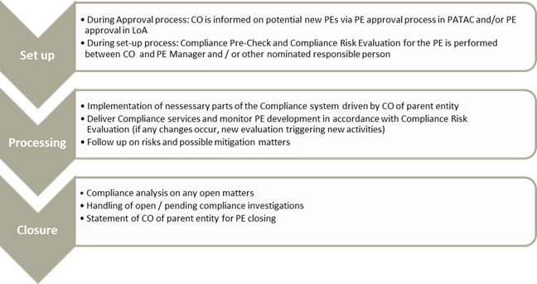Chart 1 “Overview of Compliance tasks in the PE life cycle”*

### 7.3.1. Set up

When a PE will be established, this PE must be reviewed to identify the needs and scope of Compliance services. In order to enable a focused and risk-oriented analysis, a pre-selection of scope is recommended which takes into account the structure and field of activity of the PE.

Compliance risks inherent with a PE are typically linked to three criteria, which in general increase the risk at a PE:

* External employees being directly employed by the PE
* Business partner directly engaged by the PE
* Local bank accounts under control of the PE

If one of the above criteria is fulfilled according to the pre-check chart below, then a detailed risk assessment is required.

A schematic diagram on how to proceed with such a pre-selection is shown here:

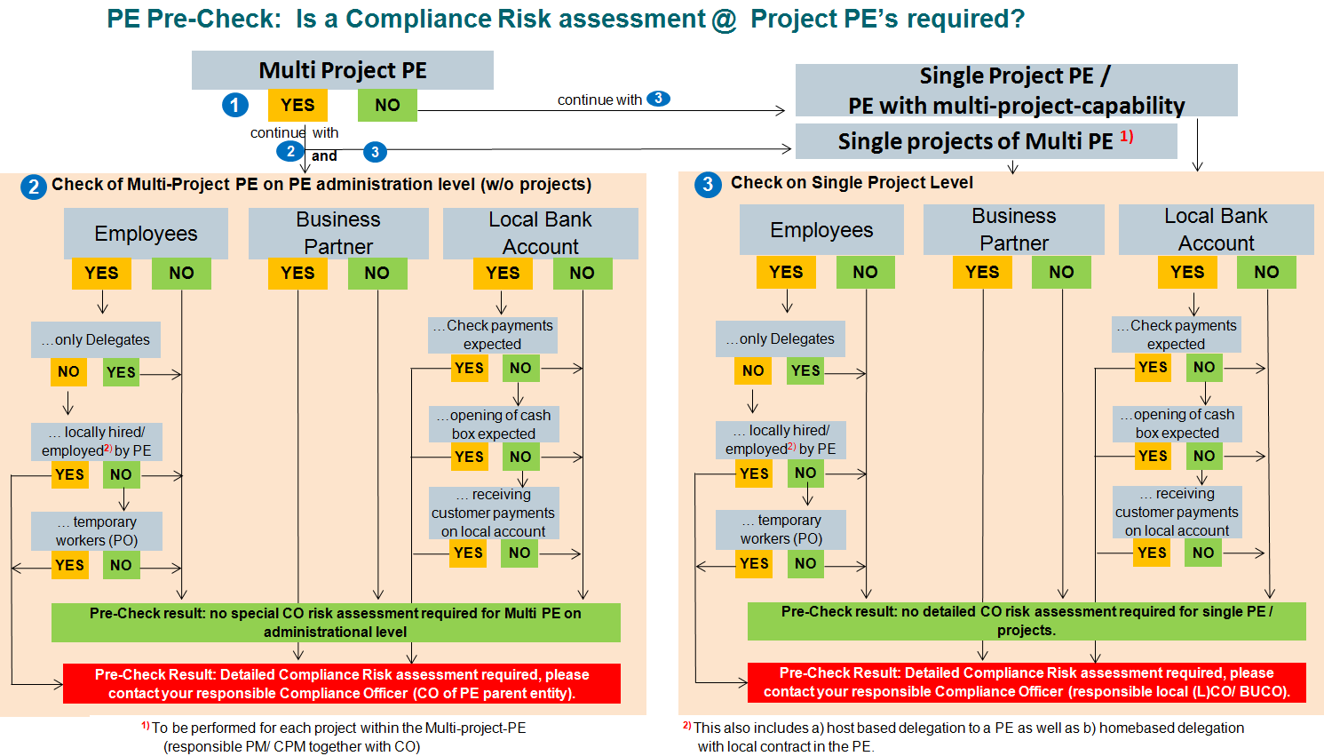

*Chart 2 “ PE Pre Check: Process to identify and mitigate Compliance Risks in a PE”*

When applicable, the PE Manager should approach the CO of the parent company in order to start this process, as the PE Manager is the first one who becomes aware of developments or changes.

In this liaison, the PE Manager and CO of the parent entity have to clarify:

* The relevant Compliance topics which apply to the PE.
* The understanding of the relevant PE employees about the applicable Compliance circulars, tools and processes.
* Any critical, potential Compliance risks and their proper handling as per our rules and regulations.

Based on the pre-selection, the affected fields of activity are to be analyzed further with a detailed questionnaire, an example can be found here: [PE questionnaire](https://findit.compliance.siemens.com/content/10000101/Compliance/LC_CO/LC_CO_STR/findIT_LC_CO_STR_7299.docx)

Based on the results, the CO of the parent company in cooperation with the PE Manager is in charge for defining the scope of the Compliance services and describing the possible Compliance risks as well as mitigation measures. To the extent necessary, the CO of the parent entity as well as the PE Manager can nominate other person(s) to be involved in or take over the clarifying, e.g. PE Coordinator, Project Manager, Regional Compliance Officer, CO in the country of activity, etc.

### 7.3.2. Processing

Since the PE develops during its life cycle, it is possible that an assessment for the PE may have to be repeated on a regular basis. In the event of major changes in the PE, the PE manager should contact his CO proactively to evaluate potential risks. Therefore, regular communication between the PE Manager and CO of the parent company is crucial.

It is to be ensured that the existing and newly identified risks have been described and properly mitigated and it is to be checked if the need for Compliance services has changed.

Particularities for PE personnel

Special attention lays on the training of the PE staff in the country of activity. To ensure this, the PE manager should inform the responsible CO asap if personnel recruitment is planned or carried out during the course of the project execution or the PE life cycle.

Like every Siemens employee, PE employees must be trained in Compliance relevant topics and understand the Compliance risks, relevant circulars, tools and processes. It is the responsibility of the responsible CO to assess whether risk-based training of PE employees is further necessary. In particular, the PE employees and staff should be able to identify critical Compliance topics and risks and bring them to the attention of the responsible CO for handling and / or mitigation.

### 7.3.3. Closure

The PE Manager initiates this process upfront PE closing by contacting the responsible CO. The PE can only be closed after all (e.g. legal, Compliance, HR and tax) obligations have been fully met.

Before the closure of the PE, a review regarding all Compliance-related issues has to be conducted to ensure that there are no open or pending Compliance topics. The responsible CO has to state the PE status regarding Compliance matters and verify that there are no open Compliance tasks.

In the event that there are pending investigations concerning the PE, the CO of the parent entity will inform Case Handling (LC CO IR CF) so that case-related issues, if any, can be taken into account before PE closing. In addition, the CO of the parent entity will check with Discipline and Remediation (LC CO IR DR) that there are no open discipline and remediation tasks.

## 7.4. Training and supporting material

Supporting documents:

* [Financial Reporting Guidelines (FRG) Implementation Guidelines](https://webbooks.siemens.com/public/FRG/IGen/)
* [ARE Masterlist](https://findit.compliance.siemens.com/content/10000101/Compliance/LC_CO/LC_CO_STR_SP/findIT_LC_CO_STR_SP_4272.xlsx)
* [PE questionnaire](https://findit.compliance.siemens.com/content/10000101/Compliance/LC_CO/LC_CO_STR/findIT_LC_CO_STR_7299.docx)

## 7.5. History of changes

|  |  |  |
| --- | --- | --- |
| **Date** | **Author** | **Major changes of binding content** |
| January 1, 2019 | Thomas Mark | First release through the Compliance Handbook.  Changes to former “Guidance for Compliance Officers in implementing the Compliance System in Permanent Establishments” (version 1.0) are: Process simplification, abolition of “ISA-I for PE's” and Compliance Service Applicability Evaluation (SAE) and introduction of a Compliance Questionnaire. |
| January 1, 2020 | Koen Miezenbeek (LC CO RFC LF) | Update due to organizational changes |
| April 1, 2020 | Yvonne Hamm-Düppe | New structure in CO Handbook, so that PEs become a new Chapter in Part 2 H.7. |
| October 1, 2020 | Ralph Nohe  Yvonne Hamm-Düppe | Editorial changes |
| April 1, 2020 | Yvonne Hamm-Düppe | Chapt. 7.1.: Transfer of possible risks of a PE from Intranet page to Handbook |

## 7.6. Contacts

Compliance Officer

The Compliance Officer responsible for your unit can be found through the following [link](https://intranet.for.siemens.com/cms/059/de/about/org/Pages/compliance_organization.aspx).

Corporate Governance Owner

The contact person for PE is:

[Ralph Nohe](https://soc.siemens.cloud/profile/Z000FA6G) (LC CO PT CO)